E-commerce APIs

🛒 What Are E-commerce APIs?
# Source: Chatgpt (GPT-5-Mini) at [1/19/2026]
E-commerce APIs are web service APIs that allow apps and websites to interact with online shopping platforms or build their own store functionalities — like displaying products, managing carts, processing orders, handling inventory, and collecting payments.
They make it possible to automate, extend, and customize online stores without building everything from scratch.

✅ What E-commerce APIs Can Do
# Source: Chatgpt (GPT-5-Mini) at [1/19/2026]
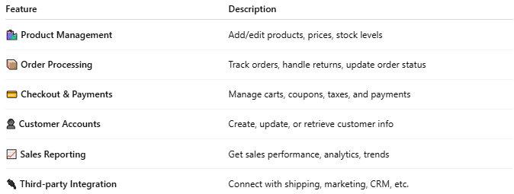

Feature | Description
🛍️ Product Management | Add/edit products, prices, stock levels
📦 Order Processing | Track orders, handle returns, update order status
💳 Checkout & Payments | Manage carts, coupons, taxes, and payments
👤 Customer Accounts | Create, update, or retrieve customer info
📈 Sales Reporting | Get sales performance, analytics, trends
🔌 Third-party Integration | Connect with shipping, marketing, CRM, etc.

🧩 Popular E-commerce APIs
# Source: Chatgpt (GPT-5-Mini) at [1/19/2026]
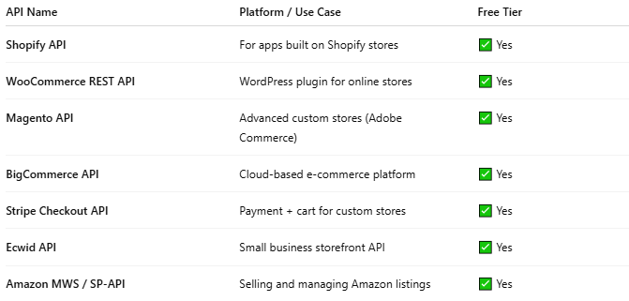

API Name | Platform / Use Case | Free Tier
Shopify API | For apps built on Shopify stores | ✅ Yes
WooCommerce REST API | WordPress plugin for online stores | ✅ Yes
Magento API | Advanced custom stores (Adobe Commerce) | ✅ Yes
BigCommerce API | Cloud-based e-commerce platform | ✅ Yes
Stripe Checkout API | Payment + cart for custom stores | ✅ Yes
Ecwid API | Small business storefront API | ✅ Yes
Amazon MWS / SP-API | Selling and managing Amazon listings | ✅ Yes

🔧 Example: Shopify Product API (REST)
# Source: Chatgpt (GPT-5-Mini) at [1/19/2026]
Request:
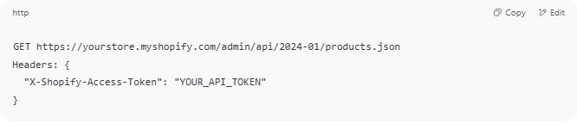
GET https://yourstore.myshopify.com/admin/api/2024-01/products.json
Headers: {
"X-Shopify-Access-Token": "YOUR_API_TOKEN"
}

Response:
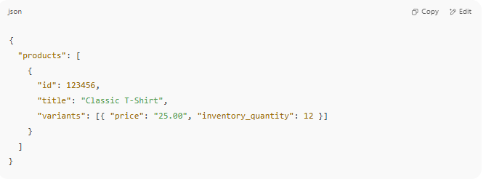
{
"products": [
{
"id": 123456,
"title": "Classic T-Shirt",
"variants": [{ "price": "25.00", "inventory_quantity": 12 }]
}
]
}

🧪 Use Cases for E-commerce APIs
# Source: Chatgpt (GPT-5-Mini) at [1/19/2026]
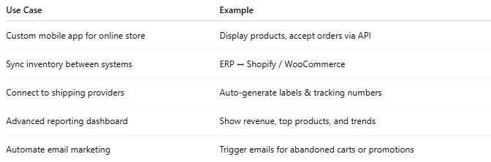

Use Case | Example
Custom mobile app for online store | Display products, accept orders via API
Sync inventory between systems | ERP ↔ Shopify / WooCommerce
Connect to shipping providers | Auto-generate labels & tracking numbers
Advanced reporting dashboard | Show revenue, top products, and trends
Automate email marketing | Trigger emails for abandoned carts or promotions

🔐 Authentication Types
# Source: Chatgpt (GPT-5-Mini) at [1/19/2026]
- API keys (WooCommerce, Ecwid)
- OAuth 2.0 (Shopify, BigCommerce)
- JWT or custom tokens (Magento, private systems)

